Life Safety Project – Address Signs
Pacific County Fire District 1
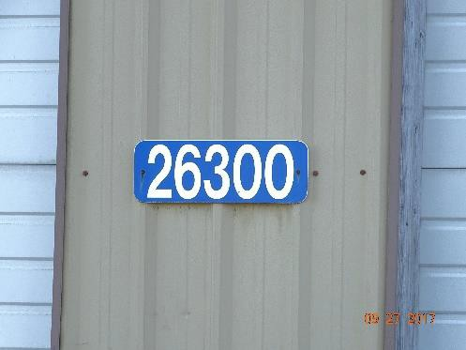
ORDER FORM Date
Name :
Address:
City:
Phone:
Address Sign Options
House Numbers 18”x6” Aluminum Panel Please indicate Vertical Horizontal. $10.00

Driveway Marker – Height 54” $20.00

Driveway is more than 600’ Yes
Qty. | Type of Sign | Address Nos. |  |  |  |  | Cost
Total Cost
MAKE CHECK PAYABLE TO:
People Saver Program
Mail this order with payment to…. Pacific County Fire District No. 1 PO Box 890
Ocean Park, WA 98640
Or drop off at: 26110 Ridge Avenue, Ocean Park

IF YOU HAVE AN EMERGENCY
CAN WE FIND

YOU?

Order an address post or sign today from Pacific County Fire District 1.

Reflective signs make it easier for emergency personnel to locate your home.

